

CST3590 Individual Project

E-Health Monitoring System

Student Name: Hugo Miguel Pinto Martins

Student ID: M00647275

Supervisor: Dr Purav Shah

Module Leader: Dr Xiaochun Cheng

10th April 2020

A thesis submitted in partial fulfilment of the requirement for the degree of Bachelor of Science in

Computer System Engineering

Abstract:

Table of Contents:

Introduction: 4

Literature Review: 5

• Pros and Cons of E-Health: 8

▪ Pros of E-Health: 8

▪ Cons of E-Health: 9

• Threats: 9

• Legal Issues: 10

▪ Licensing and reimbursement 10

▪ Data Protection 11

▪ Product Liability, 11

▪ Information to patients, 11

Approach and Methodology: 12

• Materials used: 12

▪ Arduino Mega 2560: 12

▪ MLX90614 Infrared Thermometer 14

Result Analysis: 15

Conclusion: 15

Reference List: 15

• Approach and Methodology 15

▪ Materials used: 15

• Literature Review 15

Appendices: 16

# Introduction:

Now a days a considerable amount of hospitals and GP’s struggle to assist all his users, for example in simple

# Literature Review:

E-Health was born between 1999 and 2000 and is a combination of a several of electronics and a remote communication to a Doctor or Database. Is also a service that share or modify the information through technology, but E-health is more focus in sending the user health data [1]&[2]. The need to improve the health service and relieve the hospitals from people just going there for example to just book an appointment with a Doctor or Nurse, or even request medication by medical prescription. And now they can do it thought the phone or Website.

Since the conception of E-health in 1999 and 2000, there has been more and more usage of it and there is why the rise of data in the database. This program transformed the Health Systems of the countries that are using it. As for example, before all the Health data was recorded manually by health system staff, although now a days all the data goes to a server that is safely secure, and in case of any malfunction or destruction of that server that will be back up of all the health data of the patients.

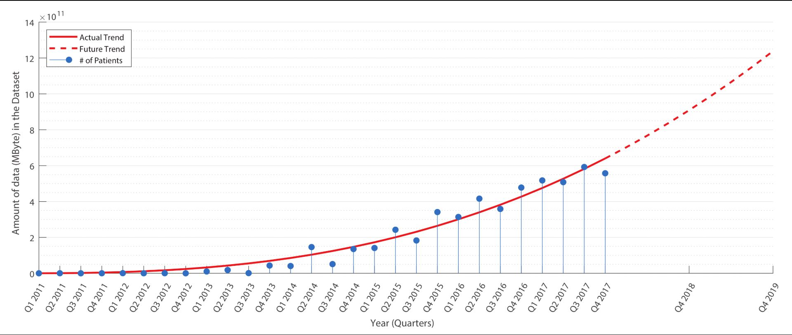

Figure 1 - Amount of data(MB) in the Database

Every year that passes there are more and more countries, mainly in Europe, trying to implement this System in their countries spending millions to implement it. Mostly if not almost all countries with E-Health are in Europe this is because the European Union is creating laws that “demand” the countries to boost their Health System every year.

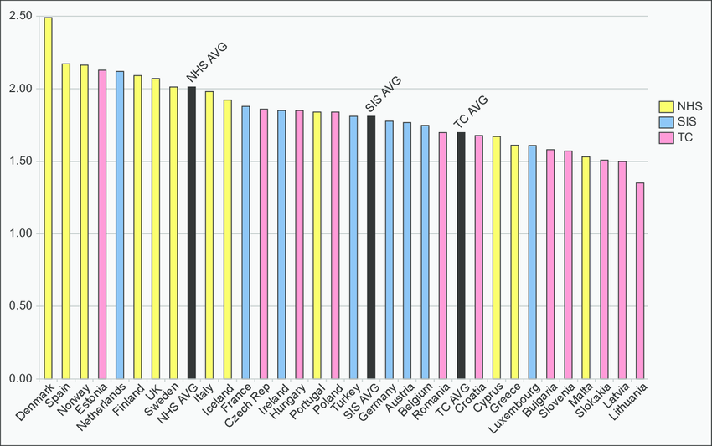

Figure 2 - The adoption of E-Health by the national health model

How it can be seen on the image on the right side, the European Union has 3 types of countries. In red the countries that don’t have at all E-Health Program and their health System is very poor like East countries, in the countries painted in yellow the program is being implemented like Italy, Spain and other ones. And at green the countries that already use the E-Health program just like almost all countries from Central Europe, North Countries and Portugal. Europe already has a lot of countries with the E-Health program (represented in green).

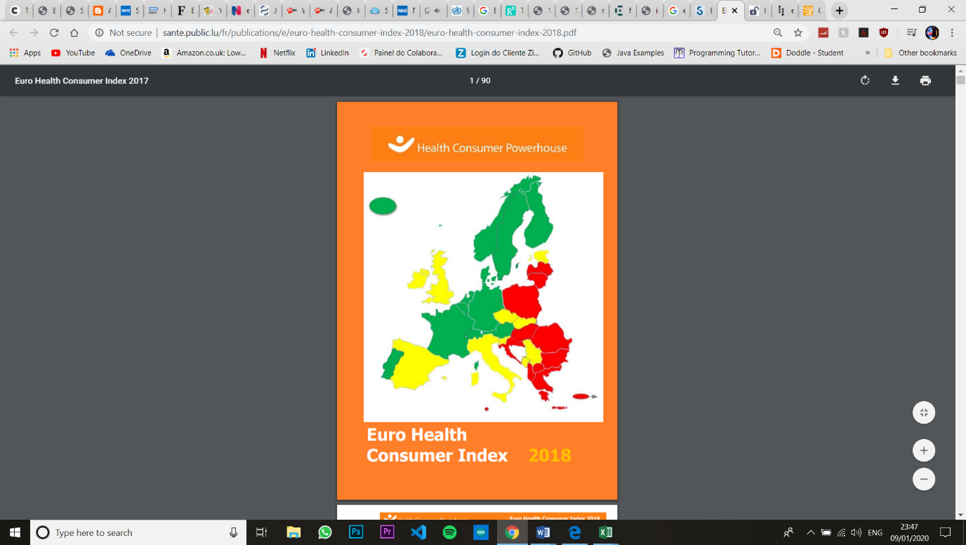

Figure 3- E-Health Europe Map

E-health can cover a lot of areas in the Health just Electronic Health record and stores all the patient data into a server. Telemedicine “exchange of information for the diagnosis and treatment of diseases and injuries, research and evaluation, and for the continuing education of health professionals” [3]. On ePrescribing the doctor can prescribe to the patient through a video or call. Big data can be used in research and development. Clinical decision support Access to decision support systems. Consumer health IT, now a days a smart watch, smartphones, Fitbit and many more can read almost all the vital signs. Knowledge Management System exhibits at the same time physical and mental characteristics, that all the organizations embraced [4].

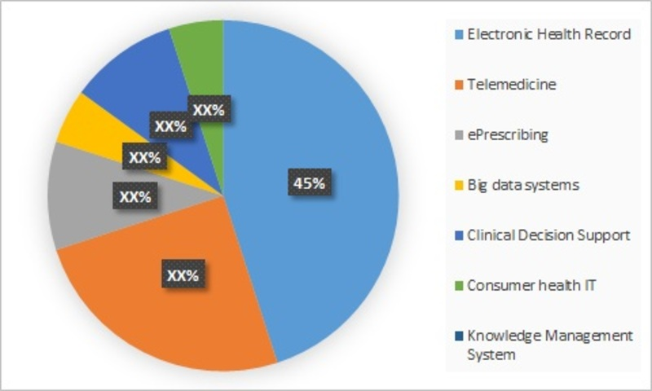

Figure 4- E-Health Services

## Pros and Cons of E-Health:

### Pros of E-Health:

* All the data is online, no documents are stored on paper because an online version is “safer” due to the backups ;
* Reduce queues in the hospitals for medical prescriptions and to book appointments;
* Raise the quality of the health system;
* Reasonable cheaper;
* Patient health data available everywhere, the patient can go any hospital that has E-Health and the medical team can see all patient health history;
* Data backup(s), in the online version in mandatory to do a backup in case something happens to the server.

### Cons of E-Health:

* Difficult for a country with a poor health system and economy to implement the system;
* All the patient personal data is online so any hacker can try to get into the servers and get all the patient personal data;

## Threats:

E-Health online threats are a big problem due to, in the database sometimes not only is has the patient health data with also sometimes contain financial information. Another big security threat are uneducated staff, they have big a role in the security of the system and if one is using a computer or laptop of the hospital and if installs some program or the website installs something into the computer that software or file just downloaded could a ransomware, if so that ransomware encrypt or lock essential services or even encrypt all the patient health data from the database [5].

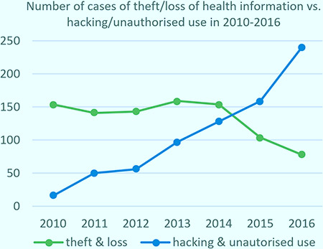The cyberattack on the 20th May 2017 that hit NHS, Hospitals and GP surgeries trough out England and Scotland is a good example of an cyberattack to the National Health System and it was called the biggest ransomware attack in history. The hackers send to the NHS staff that would seduce the reader to press the link in the email. Once the reader pressed the link, the ransomware block almost all desktop, laptop of hospital, all the email accounts were shootdown and encrypt some files on the NHS server. All the staff were affected so all of them were forced to go back to the old method, pen and paper . All that the ransomware was demanding was something between 300$ and 600$ worth of bitcoin to a specific bitcoin wallet address. A lot of doctors in England were forced to send their patient home and cancel the appointment [6].

And in this graph on the right side can confirm that the hacking & unauthorized used have increase regularly since 2010. But for the other end the cases that end in theft & loss of information has been decreasing.

## Legal Issues:

* Licensing and reimbursement, in connection to repayment of E-Health administrations, the EU Order 2011/24/EU gives the lawful system permitting patients to have their telemedicine administrations repaid indeed if given in a nation distinctive from their home country or residence country. Typically given that they drop inside the scope of repaid administrations in their nation of home and given that (in a few circumstances) they gotten an earlier authorization from their nation of home.
* Data Protection, in specific the up and coming EU Information Assurance Direction will give, among others, for a notice commitment in case of information breaches to the competent controller and the influenced individuals. An increment of fines up to 4% of the worldwide turnover of the past budgetary year. The commitment to actualize a security and security by plan approach.
* Product Liability, European controls on item obligation are exceptionally rigid and set out an administration of strict/ objective risk i.e. in case of failing patients should demonstrate as it were the imperfection to bolster their claim for harms and the burden of confirmation should be on makes to demonstrate that he harms were not caused by the charged deformity. The matter is indeed more complex within the case of telemedicine and E-Health administrations since a wrong treatment might for occasion be due to a delay within the communication of information by the telecom carrier and this information given to specialists might not be completely dependable. This would increment the hazard introduction for both specialists that shall depend on wrong information and producers of telemedicine administrations whose obligation may be connected to circumstances out of their control.
* Information to patients, since telemedicine and E-Health administrations frequently depend on information created by gadgets utilized by patients themselves, in arrange to form such information solid and valuable for the arrangement of medicines, the data and enlightening given to patients are pivotal. And indeed, typically one of the most themes secured by the Italian rules on telemedicine. The Italian rules on telemedicine, moreover, endorse enlightening on the necessities to be met in terms of benefit levels between telemedicine suppliers and healing centre’s as well as on ethical standards to be complied with. This can be subject that will gotten to be increasingly significant within the coming months/years [7].

There's no question that a key pre-condition for receiving E-Health is that both patients and experts must believe the innovation to be secure and successful. Building certainty in E-Health is, however, not close to having believe within the innovation itself. As well regularly we see at E-Health as a simple mechanical advancement in healthcare and have barely looked at the relationship between clients and innovation to recognize boundaries to acknowledgment. Components such as human interaction, changing relationship between patients and health experts have been generally side- lined , if not totally ignored , whereas there's adequate prove proposing that these components are vital to building certainty and trust. Therefore, we require subsequently to contribute assets in supporting all client bunches in obtaining the skillset required by modern interaction and ways of communication emerging from the utilize of eHealth, as well as modern parts and duties included.

# Approach and Methodology

## Materials used:

### Arduino Mega 2560:

The Arduino Mega 2560 is part of a big family of open source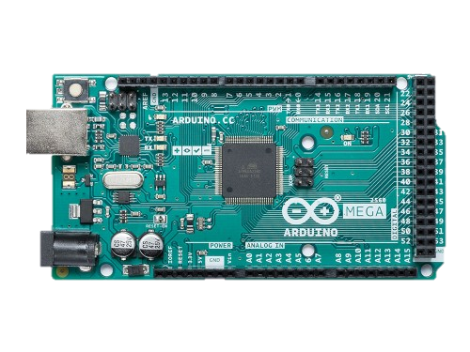 microcontrollers board but this board is based on ATmega single chip microcontroller. A microcontroller is a small IC (integrated circuit) design to controller a distinct operation in an ES (embedded system), and now a days can be found almost everywhere from vehicles, robots, home appliances among other devices. The microcontrollers are mostly a small incomplex PC (personal computer) that’s designed to operate small features of larger components, without using a complex programming language and a complex OS (operating system).[1]

Figure 1

This microcontroller needs to be power via USB 2.0 Cable Type A/B connection or connected to an external power supply. The board operates with an Input voltage limit from external power source between 6 and 20 volts. But if the power source supplies less then 7 volts the board can become unstable and malfunction. And in case the boards is supplied with more than 12 volts the microcontroller may overheat and damage the board. The recommended input voltage ranges between 7 and 12 volts. [2]

The board has a total of 54 digital pins being from pin 0-53, a digital pin is a way of representing voltage in only 1 bit being 0 (around 0v) or 1 (above 2v).

These digital pins can be used has inputs or outputs and some pins have specialized function:

* Serial 0: 0 (RX) and 1 (TX); Serial 1: 19 (RX) and 18 (TX); Serial 2: 17 (RX) and 16 (TX); Serial 3: 15 (RX) and 14 (TX). Used to receive (RX) and transmit (TX) TTL serial data o another microcontroller or others compatible boards/ sensors.
* PWM: 0 to 13 and 44 to 46. Provide 8-bit PWM (Pulse Width Modulation) output by outputting a constant frequency of ~500HZ, and the duty cycle can be changed by the ser with his own parameters. These pins are used mostly with LED’s and DC motors.
* SPI: 50 (MISO), 51 (MOSI), 52 (SCK), 53 (SS). MISO (Master In Slave Out) it’s a pin to send data to the master device in case the Arduino is connected to another device and the Arduino being the slave. MOSI (Master Out Slave In) this pin the Arduino is defined has the master device and send data to his slaves. SCK (Serial Clock) in this pin a clock signal is generated by the master device to synchronize data transmission
* LED: 13. There is a built-in LED connected to digital pin 13. When the pin is HIGH value, the LED is on, when the pin is LOW, it's off.
* I2C: 20 (SDA) and 21 (SCL). I2C is a communication protocol designed to enable communication between 2 boards using 2 wires referred to as SCL and SDA. The I2C works by giving a unique address, up to 255 devices. SCL is designed to generate a clock signal and synchronize the data transfers. SDA is used to transmit the data.[2]

This microcontroller also has 16 analog pins that can function as digital inputs or digital outputs. An analog signal is a continuous signal that can have any value between 0V and 5v sketching a signal identical to a wave.[2]

The Arduino Mega 2560 can be programmed with Arduino IDE. The programming language that the Arduino boards use is simply a set of C/C++ function that can be called from the code. [3]

### MLX90614 Infrared Thermometer:

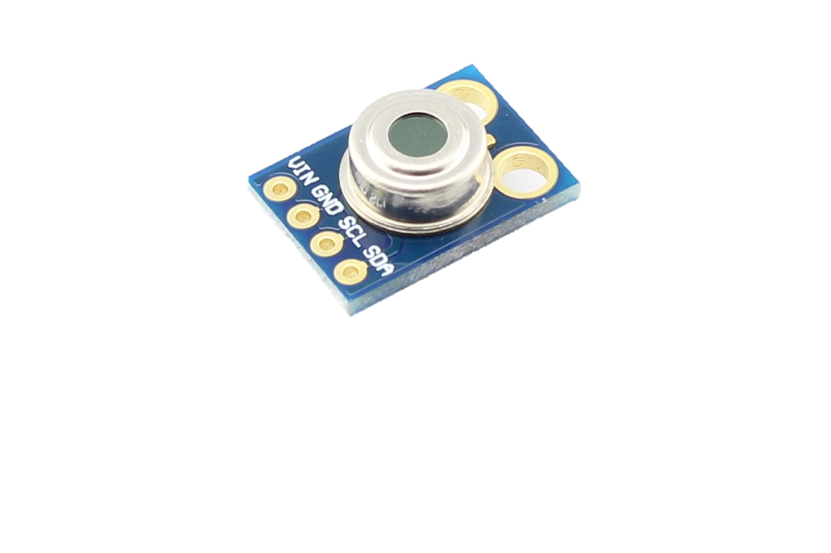MLX90614 is infrared Thermometer specifically designed for non-contact temperature readings. The sensor has integrated on his board an IR (Infra-Red) sensitive detector chip, the sensor has a temperature readout resolution of 0.01°C giving this sensor a phenomenal accuracy. The board has a wide temperature range, -40°C to +125°C for ambient temperature and -70°C to +380°C for object temperature. The output of the sensor can be configurated in two ways, by digital output connecting to the PWM pin of a microcontroller, connecting the GND pin to ground, join SDA to a PWM pin of the microcontroller, attaching Vin to a 5V power source, join SCL and Vin and inserting a capacitor of 0.1µF between the junction of SCL with Vin, and ground. Or using I2C pins, by connecting the pins SDA and SCL to the SDA and SCL pins in the microcontroller, connect GND and Vin to ground and a 5v power source, and also inserting a capacitor of 0.1µF between the junction of SCL with Vin, and ground. By outputting using the I2C the user could add more different sensors or even more than one MLX90614 by just changing the address of the sensors. And the user would use only 2 ports leaving unoccupied rest of the other ports. This method helps if the microcontroller doesn’t have a large amount of ports but will have a I2C port.

Figure 1 - MLX90614 Infrared Thermometer

The operation of the MLX90614 is controlled by an indoor state machine, which controls the measurements and calculations of the object and ambient temperatures and does the post-processing of the temperatures to output them through the PWM output or the I2C compatible interface. The ASSP (Application Specific Standard Product) supports 2 IR sensors. The output of the IR sensors is amplified by a low noise low offset chopper amplifier with programmable gain, converted by a Sigma Delta modulator to one bit stream and fed to a strong DSP for further processing. The signal is treated by programmable (by means of EEPROM contend) FIR and IIR low pass filters for further reduction of the band width of the input to realize the specified noise performance and refresh rate. The output of the IIR filter is that the measurement result and is out there within the internal RAM. 3 different cells are available: One for the on-board temperature sensor and a couple of for the IR sensors. supported results of the above measurements, the corresponding ambient temperature Ta and object temperatures To are calculated. Both calculated temperatures have a resolution of 0.01˚C. the info for Ta and To are often read in two ways: Reading RAM cells dedicated for this purpose via the 2-wire interface (0.02°C resolution, fixed ranges), or through the PWM digital output (10 bit resolution, configurable range). within the last step of the measurement cycle, the measured Ta and To are rescaled to the specified output resolution of the PWM) and therefore the recalculated data is loaded within the registers of the PWM state machine, which creates a continuing frequency with a requirement cycle representing the measured data. [1]

### MAX30102 Blood Oxygen/Heart-rate

The MAX30102 is a combination of 2 different sensors all in one sensor, has incorporated a heart rate monitor, blood oximeter sensor in a LED reflective solution, the board operates with 5v power source and only can communicate through the I2C interface. This sensor can be found in a lot of smartphones, smartwatches, tablets and fitness devices due to his small form factor and ultra-low power consumption when used. The sensor operates by shining a LED and a IR (Infra-Red) LED when the user places a finger on top of the MAX30102 sensor and depending on the code that the user has on the microcontroller the sensor can read the heart-rate or read the amount of oxygen on the blood.

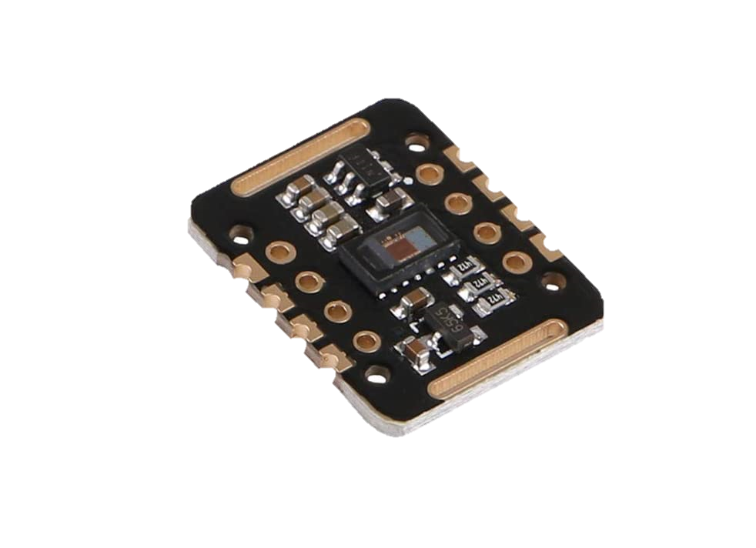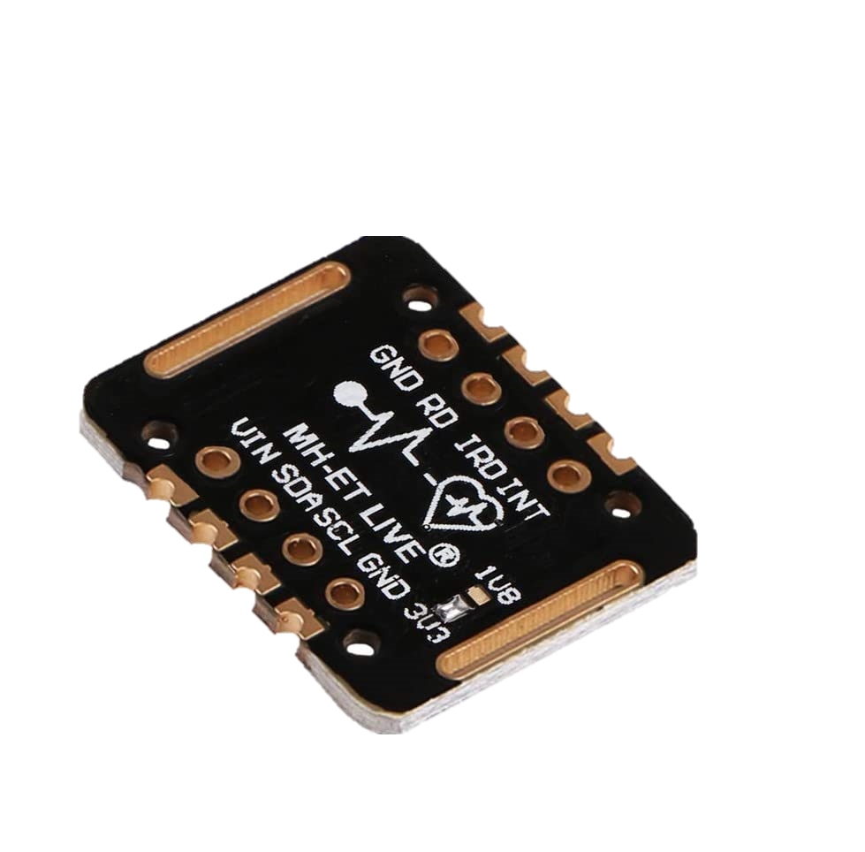

# Result Analysis:

# Conclusion:

# Reference List:

## Approach and Methodology

### Materials used:

#### Arduino Mega 2560

[1]- https://internetofthingsagenda.techtarget.com/definition/microcontroller

[2]- https://www.mouser.com/catalog/specsheets/ArduinoBoardMega2560.pdf

[3]- https://www.circuito.io/blog/arduino-uno-pinout/

Figure 1- https://www.antratek.com/arduino-mega-2560

#### MLX90614 Infrared Thermometer

[1] - https://www.mouser.co.uk/pdfDocs/901090614-706680.pdf

Figure 1 - http://arduinolearning.com/code/mlx90614-infrared-thermometer.php

## Literature Review

[1]- https://www.mdpi.com/2078-2489/10/2/34/htm

[2]- https://www.slideshare.net/moniefeied/ehealth-5196362

[3]- https://apps.who.int/iris/bitstream/handle/10665/252529/9789241511780-eng.pdf?sequence=1

[4]-https://www.researchgate.net/publication/225977285_ Knowledge_Management_and_E-Health

[5]- https://consoltech.com/blog/security-threats-healthcare-systems/

[6]- https://www.telegraph.co.uk/news/2017/05/13/nhs-cyber-attack-everything-need-know-biggest-ransomware-offensive/

[7]- https://www.gamingtechlaw.com/2014/05/top-5-legal-issues-ehealth.html

[8]- https://www.eu-patient.eu/News/News-Archive/The-future-of-eHealth-is-already-here/

# Appendices: